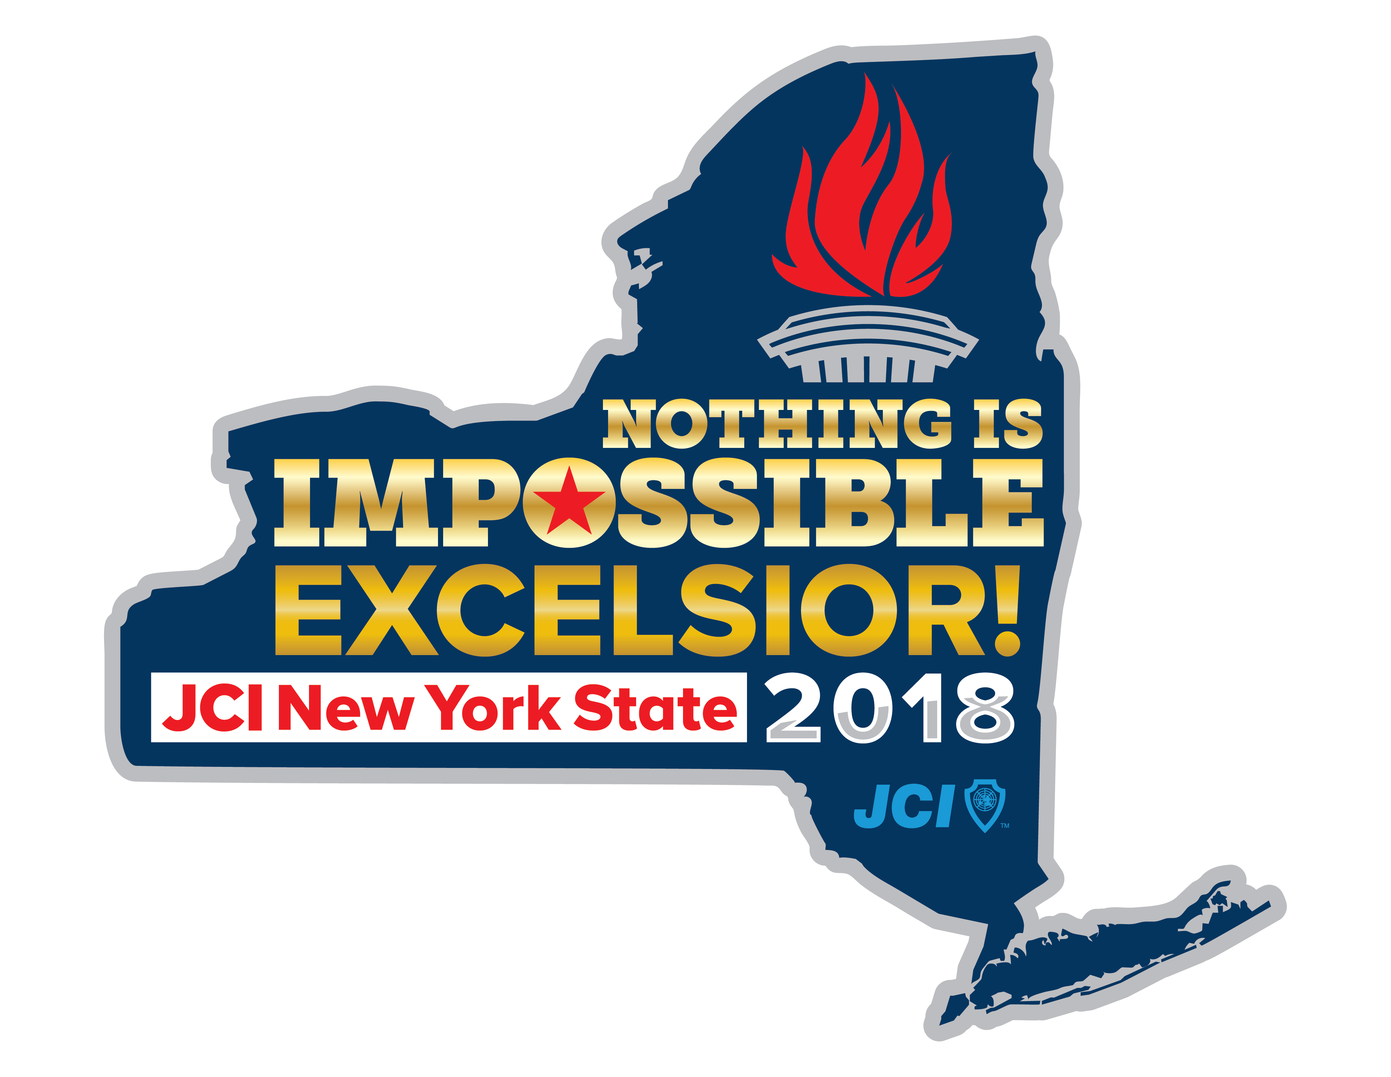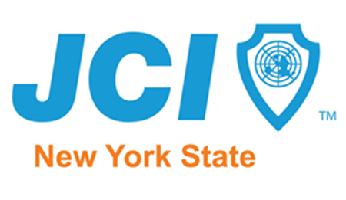
2018 New York Junior Chamber Local Projects / Programming / Public Relations Awards Nomination Form
Trimester (Trimester # ) ("" as appropriate) - PMG Supplement Must accompany award submission to be considered--- ***Please only one submission per area & per form please****

- Outstanding Local Project in Management area (1)
  - Local Economic Development
- Outstanding Local Project in Individual area (1)
  - Local Personal Skill Development
- Outstanding Local project in Community area (2)
  - Long-Term Local Community Empowerment
  - Local Corporate Social Responsibility
- Outstanding Local Project in Membership area (1)
  - Local Growth and Development
- Outstanding Local Project in International area (2)
  - Outstanding Inter-organization Collaboration

  - Local United Nations Sustainable Development Goals (UN SDG) Project (select one):

- No Poverty  - No Hunger  - Good Health  - Quality Education  - Gender Equality  - Clean Water and Sanitation  - Renewable Energy  - Good Jobs and Economic Growth  - Innovation and Infrastructure | - Reduced Inequalities  - Sustainable Cities and Communities  - Responsible Consumption  - Climate Action  - Life below Water  - Life on Land  - Peace and Justice  - Partnership Goals

- Outstanding New Project of the trimester
- Outstanding Local use of Public Relations or Marketing project
- Outstanding Local Website and/or Newsletter
- Outstanding Local Chapter Corporate Sponsorship award

Award Entry submission must be submitted via email to awards@newyorkjaycees.org on or before 11:59pm January 2, 2019 (Projects completed 09/01 - 012/31/2018)

Please consider the following local project or program for the recognition indicated above:
Name:
Area of Opportunity:

Membership
Membership table at this project ____YES ___NO
Membership information at this project ____YES ___NO
% of members involved/attended ( )
# of prospective members involved ( )
NEW MEMBERS RECRUITED FROM THIS PROJECT (__)

NAMES and email address
Project/program chair/co-chairs and supervising chapter officer: ("X" or "" for chair/co-chairs)

PMG Supplement:
Project Name: State: New York State
Please provide as much tangible, measurable information as possible to allow judges to clearly see the impact this project has had on the organization, members and community and why this project deserves to be recognized with this award.
Date(s) of the project:
Sponsors:
Project Budget: $
Profit/Loss for the Project: $
Who benefitted from this project?:
What was the primary purpose of the project?:
Overview of the project (Describe the project in detail, including history and goals):
Results/Outcome (Share the results of the goals reported above.):
What steps were taken to complete project?:
What were the objectives of the project/program? (List what you hoped to accomplish with the project.):
How does this program align to the JCI Plan of Action? (How does the project align with the chapter's plan of action?):
Was the budget an effective guide for the financial management of the project? (Describe the use or non-use of a budget to run the project.):
How does this project advance the JCI Mission and Vision? (Explain how this project provides development opportunities for young people to create positive change.):
By number, how many members were involved in this project?:
By percentage of January 1 membership, how many of the Local Organization's members were involved in this project?:
Describe the main roles of the participating members of the program. (List manpower of the members involved in the project.):
How did the Local Organization measure community impact of the program? (Describe how you measured the impact the program made in the community.):
Describe the actual community impact produced by this program. (Use tangible descriptions where possible.):
How did the Local Organization benefit from running this project? (Use tangible descriptions where possible.):
How did the program advance the JCI Mission - "to provide development opportunities that empower young people to create positive change"?
How did the project advance the JCI Vision - "to be the leading global network of young active citizens"?
What is the expected long-term impact of this project? (Explain the long term impact this will have on your chapter, community and individual members.):
What changes would you make to improve the results of this project? (List suggested changes to make improvements to the project for the future.):
Publicity and Promotion (List any and all external & internal) ______________________________________________________________________________________________________________________________________________________
MANDATORY!-Attach pictures and documentary evidence, contracts, publicity & other relevant continuation info. PMG Supplement entries ARE REQUIRED. Newsletter entries will include at least each edition's first page. Tell us what IMPACT this project left on the chapter, members & community or how the chapter event relates to creating positive change in your local community or within your members.
Submitted by:

Name: |  | Position:

