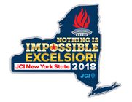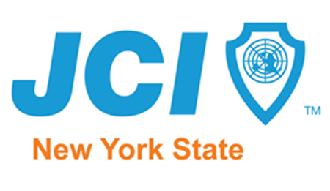
2018 New York Junior Chamber Local Individual Members Trimester awards
Check one  (Trimester Awards__) (Year End )

- Outstanding Local Chapter Vice President
(One for each Area of Opportunity: Management VP, Individual VP, Membership VP, Community VP, International Affairs VP)
- Outstanding Local Chapter Officer
- Outstanding New Jaycee (less than 6 months)
- Outstanding Jaycee member
- Outstanding Junior Jaycee/Jaycee Kid
- Outstanding Very Important Partner

Award Entry submission must be submitted via email to awards@newyorkjaycees.org & awards@jcinewyork.org on or before 11:59pm January 2, 2019 (Projects completed 09/01 - 12/31/2018)

Please consider the following Jaycee for the recognition indicated above:
Name: | Position Held:
Chapter:
Projects/programs chaired, supervised, or attended (name and date): ("✗"or"✓" if chair/supervisor)
District, region, state, national, or international Jaycees events attended (name and date):
Trimester# __:
# of new members this person recruited( )
% of chapter activation: (__)
# of members helped in Passport to Leadership program: (__)

Please provide as much tangible, measurable information as possible to allow judges to clearly see the impact this member has had on the organization and why this member deserves to be recognized with this award.

When did this member join JCI?:

What was the member's focus/goals for the year? (Please also comment on the outcomes of these goals.):

How has this member demonstrated leadership, motivation and inspiration of other members?

What has been this member's community impact during the quarter?

What has been this member's impact on the local chapter/state/national organization?

What has this member's participation been in the local, state, national and international JCI events?

How does this member exemplify JCI USA mission, vision and values?

MANDATORY!-Attach narrative, pictures and documentary evidence, and continuation info. Narrative should include all publicity and promotion; relationship to chapter plan; and impact on chapter, members, and community.

Submitted By:

Name | Position

